REPORT FROM THE DEUTSCHE FORSCHUNGSGEMEINSCHAFT –DFG

"Supplementary instructions for funding proposals concerning research projects within the scope of the Convention on Biological Diversity (CBD)”

INTRODUCTION
This is a report from the DFG Senatskommission für Biodiversitätsforschung (SKBDF, Senate´s Commission on biodiversity research of the German Research Foundation) summarizing the experience accumulated by DFG since 2008, on the adoption of "Supplementary instructions for funding proposals concerning research projects within the scope of the Convention on Biological Diversity (CBD)”.
This report is submitted upon request of the BMU, as a contribution to the report of the European Union that will be sent to the 3rd meeting of the Ad Hoc Open-ended Intergovernmental Committee for the Nagoya Protocol on Access and Benefit-sharing (ICNP 3), for the better understanding of the use of voluntary guidelines, standards, model contractual clauses, codes of conduct and best practices, related to articles 19 and 20 of the Nagoya Protocol on Access to Genetic Resources and the Fair and Equitable Sharing of Benefits Arising from their use, which was adopted by the 10th Conference of the Parties of the biodiversity convention.

BACKGROUND
DFG (the German Research Foundation) is a private organization under public law (public funds). Its duty is to fund basic research in Germany. It covers all branches of science and humanities granting funds for individual research projects and facilitating cooperation among researchers. Just in the past year, DFG has provided funding for around 30 000 projects, 38% of which were on life sciences. DFG facilitates international collaboration with German researchers through different programs and initiatives. It also has established agreements of cooperation with counterparts in at least 27 countries outside Europe.

Since 2002, DFG is running a working group on CBD-related issues, in particular in matters related to access to genetic resources and benefit sharing from their utilization (ABS). This coincided with the adoption of the Bonn Guidelines by the COP. The DFG-ABS working group advices the Senate

commission on biodiversity research (SKBDF) in subjects resulting from the implementation of the Convention on Biological Diversity (CBD). It takes part in international discussions on ABS, particularly advocating for the requirements of basic (non-commercial) biodiversity research, on facilitated access, according to what has been established in article 8a of the Nagoya Protocol.

DFG is the sole funding institution in Germany engaged in undertaking actions to incentivize compliance with ABS regulations and promote due diligence, to avoid cases of scientific miss-appropriation of genetic resources or traditional knowledge.

Upon its establishment, the working group on CBD/ABS, consisting of biologists and lawyers, decided to prepare the guidelines for research applications in biodiversity related subjects, to facilitate compliance with the spirit of the CBD and national rules and procedures, in provider countries. The draft of these guidelines was presented in 2006 to the DFG, having accomplished the process of legal approval by May 2008. These guidelines were presented then, at the Ninth Conference of the Parties of the CBD, held in Bonn. Since then, they have been cited and referred to several times, and can be found at the DFG web page, as well as on the CBD's website. At present, the ABS working group consists of biologists, economists, lawyers and representatives of the pertinent Federal Ministries as permanent guests.

The working group was represented at the "Informal Meeting for the Implementation of Articles 19 and 20 of the Nagoya Protocol" convened from 25th – 26th March 2013 in Tokyo, Japan by the United Nations University Institute of Advanced Studies, in conjunction with the Ministry of Foreign Affairs, Japan and the Secretariat of the Convention on Biological Diversity (CBD), with a presentation on the experience of “DFG guidelines for non-commercial/basic research”.

THE LEGAL FRAMEWORK (WITHIN DFG, GERMANY AND THE EU)

Germany became a signatory country of the Nagoya Protocol on June 23, 2011. Ratification is still pending and there are, so far, no obligatory legal regulation concerning access or benefit sharing derived from the utilization of genetic resources. Thus, the establishment of the guidelines by DFG was a voluntary act, but they are obligatory for research projects applying to DFG.

OVERVIEW OF THE GUIDELINES AND CURRENT IMPACT ON PROCEDURES

The guidelines or supplementary instructions aim to facilitate compliance by researchers and to avoid problems that may arise during the research process, when planning biodiversity research in foreign countries and establishing collaborations.

Currently, while preparing an application for DFG funds, researchers are requested to assure knowledge of the process and ABS regulations of the country where the research will take place (figure 1). If this is not clear in the proposal, DFG contacts the researcher to clear the case. Researchers are always also recommended to establish local collaborations.
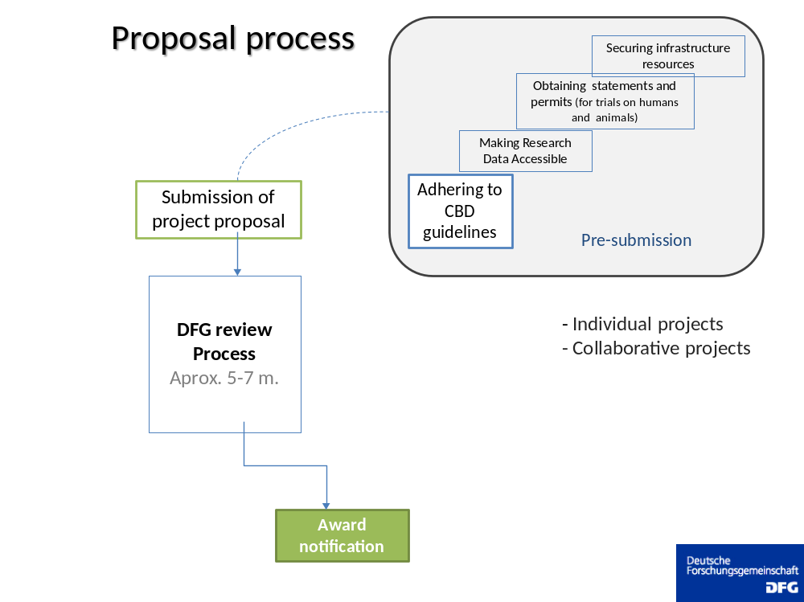

FIGURE 1. Flow-chart of a biodiversity-related project for which funding by the DFG is requested. Previously to submitting and application for the review process, applicants are requested to familiarize themselves with ABS and have established contact with potential partners and with authorities dealing with ABS, from the countries where they will be running their research.

The amount of work undertaken for reviewing biodiversity-related proposals by DFG is significant. In the course of the past five years (from January 2008 to July 2013), DFG has received and processed 1810 proposals in the fields of plant evolution, plant-ecology and ecosystems research, organismic - interactions, systematics and morphology, evolution, biodiversity and ecosystem functioning anthropology, animal ecology, ,and physical geography. During that period, 42 % of the proposals have been approved. Of these projects, around 400 work with biological material from in-situ and ex-situ collections, for a wide range of topics, from taxonomy to conservation, biogeography, chemical ecology, and others. Nearly 55% of the projects access material from around 50 different countries. The remaining projects will use stock material in Germany, other European and developed countries and the USA, or will work with model organisms. A small percentage (< 5 %) will also use genetic material stored in collections in developing countries or in countries in transition, where well established ex-situ collections and research partners exist.

A more detailed analysis made in 2008 reported that within five months (after the adoption of the guidelines), 10 out of 14 projects working in 23 countries (from Africa, Latin America and Eastern Europe) sampled genetic material from animals, 4 from plants and 7 projects included collaborative research together with scientists from developed countries. Of all these countries, only one third had clearly identifiable contact addresses and only 5 had ABS rules. This analysis characterizes the situation regarding information for compliance by researchers, still up to now.

Recent interviews about the use of the guidelines, provided the following insights:
- The guidelines provide important initial guidance towards the process of requesting access to biological and genetic material in general, in accordance with CBD requirements.
- As every country has developed or is in the process of developing own rules and procedures, following those steps can sometimes be very long and complicated (because procedures are not clear or are constantly changing).
- Even when the interviewed researchers did not had to sign an ABS contract, all were aware of other procedures in place, such as research permits, export permits or even sanitary certificates.
- Counterparts from the foreign country and colleagues from Germany or other European countries frequently help in the process of gaining legal access and permits or provide valuable information on how to proceed.
- Knowledge of the language of the provider country is very important, especially when visiting local authorities to explain the research plan.
- There is a number of model standards for basic/non-commercial research already agreed upon between researchers from user countries and authorities of provider countries. Some of the most common points are:
  - Collaboration with local partners, most desirable but not necessarily on the basis of institutional agreements (MoU).
  - Participation by counterparts or students in field work which results in capacity-building at different academic levels. If possible visits of students or partners in German universities or research centers should be arranged.
  - Sharing of data, especially information on the samples taken in the provider country (scientific names, geographical and political location), and of the results of studies.
  - Sharing of results is usually made in the form of a scientific publication; but additional material such as pictures, should be provided, as well as accesibility to data bases.

- Knowledge about the CBD (and the Nagoya protocol) and the relevant obligations is not as widespread in the German scientific community as one would expect. Therefore, the guidelines contribute to highlight the CBD/ABS objectives and related legally binding regulations.
- Capacity building and technology transfer are benefits more difficult to share when conducting research in several countries at a time, as in taxonomy and systematic, when time and resources must be split and shared among more countries, or for small projects. Instead, long-term collaborations in single countries bring much more benefits to provider countries.
- The exchange of experiences among German researchers dealing with ABS procedures in provider countries is very important for finding the appropriate steps and authorities.

OUTLOOK FOR FUTURE WORK UNDER THE SCOPE OF THE NAGOYA PROTOCOL

With the adoption of the guidelines in 2008, DFG demonstrated its commitment to contribute to the achievement of the ABS /CBD objectives in compliance with the Nagoya Protocol, however its relevant functions are limited by its legal nature.

At the moment, the working group is preparing a document with model clauses, to better advise the contract partners, when establishing agreements for access to genetic resources and collaborations in accordance with the Nagoya Protocol. The group has also work underway, to gain information about the use of the guidelines, and to update the current version in agreement with the expected European and German regulations and law, respectively. However, as the current version does not contradict the NP principles, and since the European and German regulations are not yet decided, the Guidelines are still applicable.
In light of the information gathered for this report, we support and encourage the prompt establishment of the ABS clearing – house Portal (ABSCH), which is now at its pilot stage (see https://absch.cbd.int/home). We believe it will greatly facilitate to follow the procedures for legal access by the biodiversity community in accordance with the ABS specificities of each country. It should also provide information when there is no ABS regulation in place, what alternative procedures exist.
Additionally, we are prepared to conduct a side-event during the 3rd meeting of the Ad Hoc Open-ended Intergovernmental Committee for the Nagoya Protocol on Access and Benefit-sharing (ICNP 3), to report more thoroughly on the use of the guidelines and the array of benefits derived from non-commercial research.
For the time being, DFG will continue to participate in international and national discussions, to ensure that guidelines and other recommendations for researchers are in agreement with legal and conceptual frameworks and that facilitation of access procedures for non-commercial research, as indicated in Article 8a of the Nagoya protocol, is particularly taken into account.

http://www.cbd.inťabs/resources/contracts.shtml.
“Guidelines for Basic Researchers, DFG´s Experience” by Monica Ribadeneira Sarmiento, presented at Bonn, ABS Basic Biodiversity Research Workshop 14 – 20 November 2008.

