State Scientific Institution “Institute of Genetics and Cytology, NAS of Belarus”
Having considered the letter of the State Scientific Institution “Institute of Genetics and Cytology, NAS of Belarus” of December 28, 2017 No. 271-08/1265, the Ministry of Natural Resources and Environmental Protection of the Republic of Belarus confirms that the transfer of the genetic material of three (3) potato lines: SvSvl (tissue culture), SvSv2 (tissue culture) and IGC10/1.21 (tubers) developed at the Institute of Genetics and Cytology, NAS of Belarus to the Potato GeneBank of the US Department of Agriculture for research (non-commercial use) shall be carried out on Mutually Agreed Terms for joint use of the transferred genetic resources and sharing of prospective (in-kind) benefits concluded between the Institute of Genetics and Cytology, NAS of Belarus and the Potato GeneBank of the US Department of Agriculture and in line with the requirements of the Nagoya Protocol on Access to Genetic Resources and the Fair and Equitable Sharing of Benefits Arising from Their Utilization to the Convention on Biological Diversity
Deputy Minister A.N. Korbut
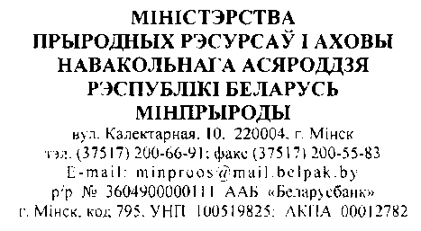
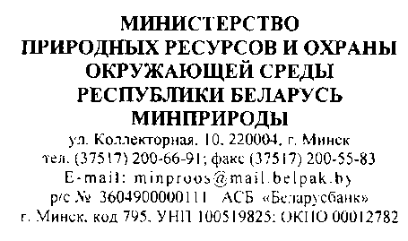
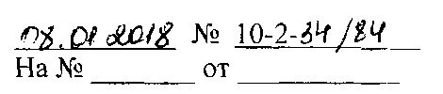
Compliance with the Nagoya Protocol requirements

